**Output explanation:**

In first line 3 complex number in the link list which were added to link list are displayed the list. Then in the second line we added the first two number in the link list and store in the list in end and then displayed the list. After that in the third line subtracted 1 and 3 number in the link list and store at last and then displayed the list. In fourth line Multiple 2 and 3 numbers and store at last then displayed the list. In fifth line shows the link list after dividing 1 and 3 complex numbers in the link list and adding it at the end. Sixth line shows that complex at no. 4 position in the link list was deleted and was added at the end.

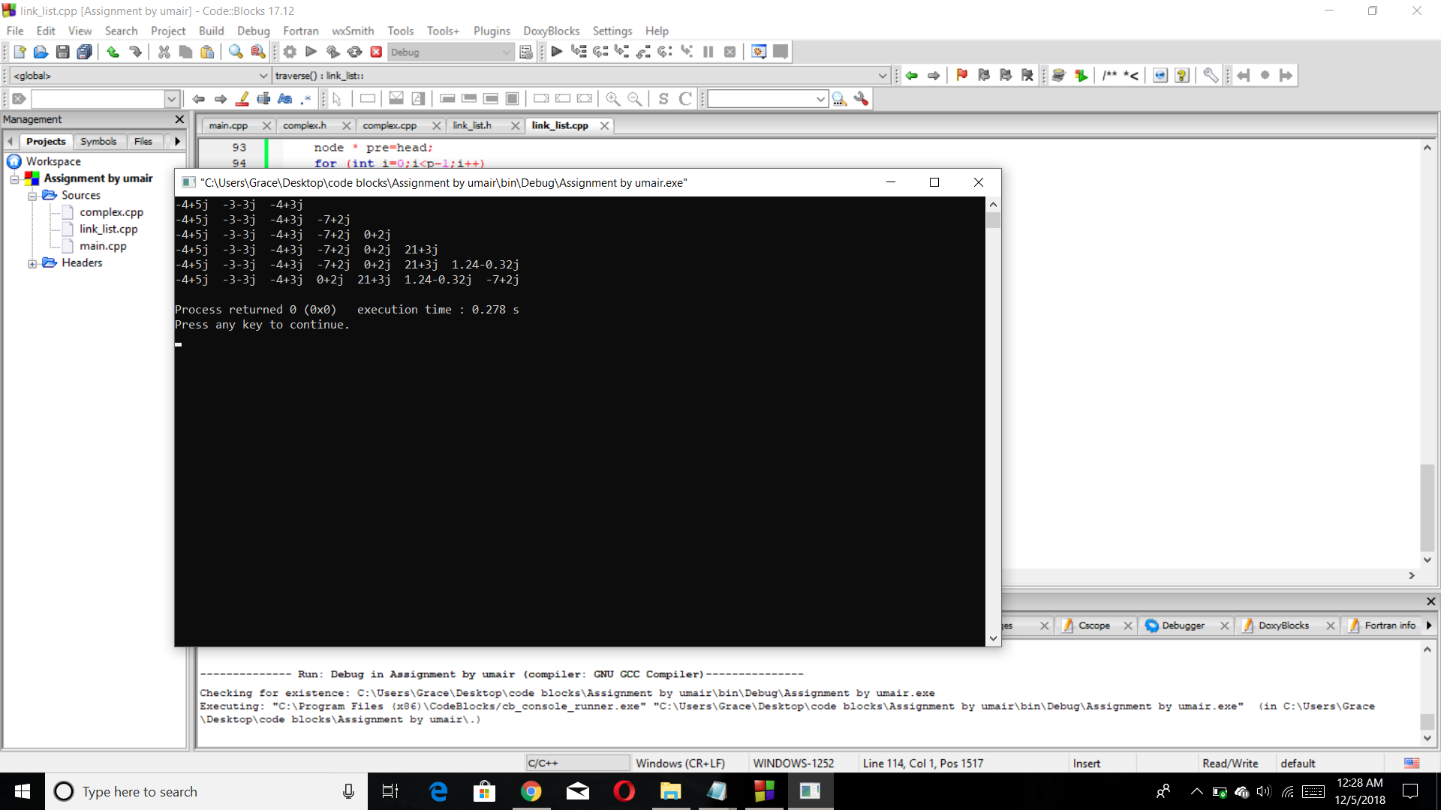

Note: the above shown output can be achieved by operator overloading and operator overloading commands are commented in the main.cpp